[1]

An Extensible Induced Position Encoding Readout Method for Micro-pattern Gas Detectors

Shubin Liu, Siyuan Ma, Binxiang Qi, Zhongtao Shen, Guangyuan Yuan, Qi An

*Abstract*—The requirement of a large number of electronics channels has become an issue to the further applications of Micro-pattern Gas Detectors (MPGDs), and poses a big challenge for the integration, power consumption, cooling and cost. Induced position encoding readout technique provides an attractive way to significantly reduce the number of readout channels. In this paper, we present an extensible induced position encoding readout method for MPGDs. The method is demonstrated by the Eulerian path of graph theory. A standard encoding rule is provided, and a general formula of encoding & decoding for n channels is derived. Under the premise of such method, a one-dimensional induced position encoding readout prototyping board is designed on a 5×5 cm2 Thick Gas Electron Multiplier (THGEM), where 47 anode strips are read out by 15 encoded multiplexing channels. Verification tests are carried out on a 8 keV Cu X-ray source with 100μm slit. The [test](javascript:void(0);) results show a robust feasibility of the method, and have a good spatial resolution and linearity in its position response. The method can dramatically reduce the number of readout channels, and has potential to build large area detectors and can be easily adapted to other detectors like MPGDs.

*Index Terms*—micro-pattern gas detector, position encoding, multiplexing readout, tracking

# INTRODUCTION

O

ver the past 20 years, Micro-pattern Gas Detectors (MPGDs) are widely used in high-energy physics, and have expanded to astrophysics, nuclear physics and medical imaging.[1][2] The conventional readout techniques employ a large number of electronic channels, which poses a big challenge to the further applications of MPGDs. By changing the readout electrode’s structure and multiplexing the readout channels, an induced position encoding technique for micro-channel plate detector was developed by D. Kataria et al. [3] in 2007. The technique was used for MPGDs by R. Hu et al. in 2011 [4], where a preliminary feasibility test was implemented with Micromegas. This technique can significantly reduce the number of readout channels, but the foregoing works didn’t provide an extensible encoding method and the decoding is complicated. In this paper, an extensible induced position encoding readout method for MPGDs is presented. The method is demonstrated by the Eulerian path of graph theory. A standard encoding rule is provided, and a general formula of encoding & decoding for n channels is derived. A prototyping design is implemented on a 5×5 cm2Thikc Gas Electron Multiplier (THGEM), and verification tests are carried out on a 8 keV Cu X-ray source with 100μm slit.

TABLE I

decoding table of 3 readout channels

|  |  |
| --- | --- |
| Channel: comparsion | Strip: position |
| CH1>CH2 | Strip 1 |
| CH2>CH3 | Strip 2 |
| CH3>CH1 | Strip 3 |
| CH1>CH3 | Strip 4 |
| CH3>CH2 | Strip 5 |
| CH2>CH1 | Strip 6 |

# Principle and method



Fig. . Induced position encoding readout schematic

## Principle

For ease of understanding, the simplified schematic is shown in Fig. 1 , where 6 strips are readout by 3 encoded multiplexing channels. Charge from detectors is collected by an anode strip and split across two induced strips which correspond to the respective readout channels. Due to the different width, charge is split unequally between the two induced strips, where the amplitude on one always higher than on the other. Based on the signal’s amplitude in corresponding channel, the hit position could be uniquely decoded as seen in Table I.

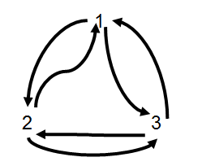

Fig. 2. An Eulerian Path

## Eulerian Path [Theorem](javascript:void(0);)

As shown in Fig. 1, 3 readout channels have ordered doublet combinations{12,23,31,13,32,21}which corresponds to 6 anode strips. The technique requires that any ordered doublet combination of channels appeared exactly once, and formed head to tail as an encoding list. Generally, the principle described above is a graph theory problem that whether there is an Eulerian path, where the doublet combinations represent the edges and the readout channels represent the vertices. Fig. 2 shows an Eulerian pathof the 3 readout channels in Fig. 1 According to Eulerian path theorem [5], it can be proved that there is an Eulerian path for n channels induced position encoding readout, as all of its vertices have an even degree. In other words, *n* channels can encode readout a maximum anode strips.

TABLE II

The encoding list of n readout channels

|  |  |  |  |  |  |  |  |  |  |  |  |
| --- | --- | --- | --- | --- | --- | --- | --- | --- | --- | --- | --- |
| Row | Encoding list | | | | | | | | | | |
| 1 | 12 | 21 |  |  |  |  |  |  |  |  |  |
| 2 | 13 | 32 | 23 | 31 |  |  |  |  |  |  |  |
| 3 | 14 | 42 | 24 | 43 | 34 | 41 |  |  |  |  |  |
| ... | … | … | … | … | … | … |  |  |  |  |  |
| k-1 | 1k | k2 | 2k | k3 | 3k | k4 | … | k(k-1) | (k-1)k | k1 |  |
| … | … | … | … | … | … | … | … | … | … | … |  |
| n-1 | 1n | n2 | 2n | n3 | 3n | n4 | … | … | n(n-1) | (n-1)n | n1 |

## Encoding and Decoding

It turns out that there are more than one constructions of Eulerian path. We need to make appropriate constraints to construct a regular and extensible encoding method so as to easily decode and design. As shown in Table 2, it is an extensible encoding list for n channels, where the list is organized in rows. The encoding form XY means that the signal’s amplitude of channel X is higher than channel Y’s.

According to the Table II, the encoding formula (1) and decoding formula (2) can be derived as follows:

(1)

(2)

## Width Ratio of two induced strips

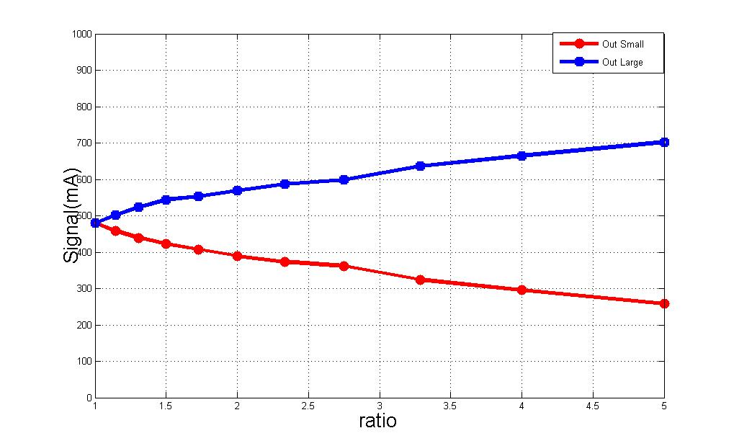

Fig. 3. The output signals of wide strip and narrow strip under different width ratio

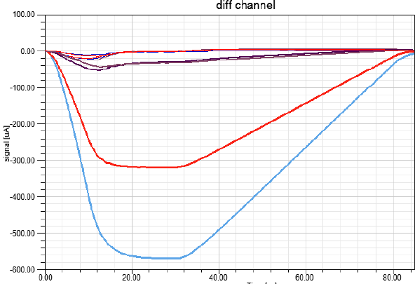

Fig. 4. Output signal of all electronic channels when ratio is 2:1

In order to study the relationship between the two induced strips, we used ANSYS's software Designer and SIwave to simulate magnitude of induced signals. The relationship between the larger signal and the smaller signal at different width ratios have been shown in Fig. 3. It's necessary to ensure that not only the signals from the two induced strip have enough difference, but also the smaller signal can be distinguished easily from crosstalk and noise. It's reasonable to take 2 as the ratio of the two strips, considering the production process of Printed Circuit Board (PCB). Fig. 4 shows the output signal of each channel when the width ratio is 2. It can be seen from Fig. 4 that the smaller signal has enough recognition degree from crosstalk. Of course, it’s much larger than the noise.

## Packet Coding Techniques



Fig. 5. Schematic of packet coding techniques

If two or more adjacent anode strips are directly encoded together, the decoding will have faults because the signal has a certain width and more than one strip is hit. To solve this problem, Packet Coding techniques are proposed. As shown in Fig. 5, the adjacent anode strips are assigned to different groups, which are encoded and decoded individually. In this way, an event with a certain width will not hit more than one strip of one group. The number of group is decided on the width of the signal and the width of the strip. Besides, by using Packet Coding method, higher position resolution can be obtained by applying finer strips.

# VERIFICATION TEST

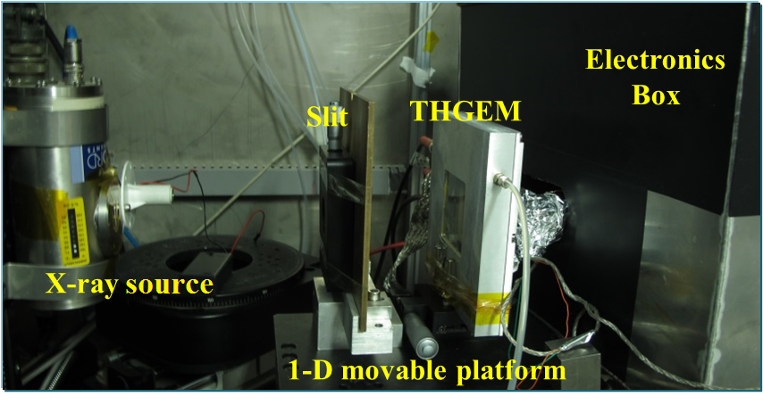

Fig. . Experimental setup

## Experiment for verification

In order to verify this method, a prototyping readout board was manufactured and equipped for a 5×5 cm2 THGEM detector[6]. To solve the case that each particle usually showers the signal on several neighboring strips, the neighboring strips are separated into three groups to encode respectively. Based on the encoding list shown in TALBE II, the prototyping board has 47 [one-dimensional](javascript:void(0);) 1.07mm strips which readout by 15 channels. According to the decoding formula, the hit strip can be decoded by the fired channels.

As shown in Fig. 6, verification tests were carried out on the THGEM detector, which is filled with Ar/iC4H10(93:7) gas mixture. A 100 μm [slit](javascript:void(0);) in a thin brass sheet was used to produce a miniaturized X-ray beam. A manual movable platform was used for the position scanning test.The electronics is based on the VATA160 chip.[7]

## Result of tests



Fig. . The signal recorded on 15 channels when an event hit



Fig. . Spatial resolution result of the detector

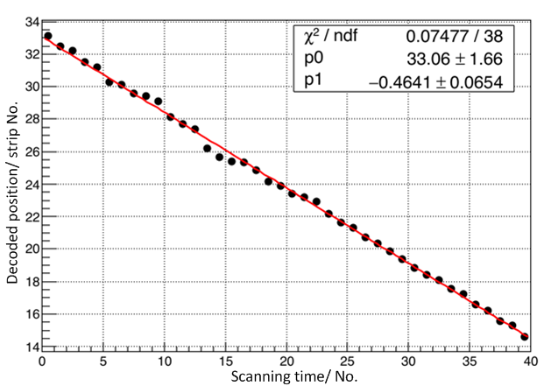

Fig. . Linear result of position scanning test

Fig. 7 shows the signals recorded on all 15 channels when an event hit. There are 47 anode strips, which are divided into 3 groups to be encoded and decoded individually, and the width of each strip is 1.07mm. The baseline noise is about 2.5fC. We take 2σ of 5fC as the noise threshold to filter the valid signals. It can be inferred that the hit channels are channel 2, channel 4, channel 12 and channel 14. Channel 2 and channel 4 belong to group A, from which the hit strip of strip 25 can be decoded. The Channel 12 and channel 14 means that strip 26 is hit, too. According to the distribution of charge on the two strips, the true hit point is strip 25.25, and the width of the event is about 2 strips, which means 2.14mm.

Fig. 8 shows the decoded spatial resolution result of the detector. The width of anode strip is 1.07mm. A large number of statistics have been made for a fixed X-ray incidence location. If the threshold is set to twice the noise, the correct rate of decoding can reach 94%. The root-mean-square (RMS) of the statistical histogram is 1.69 strips, which mean the resolution is 1.8mm.

Fig. 9 shows the results of linearity in the position scanning test. The test setup has been shown in Fig. 6. During the test, the detector was moved with a step of 0.5mm every time. The X-axis of Fig. 9 represents the No. of the scanning, and Y-axis means the decoded anode strip of each time. P0 shows the slope of the fitted red line, which means the step of every movement is 0.464 strips (0.496mm). It's very close to the ideal step of 0.5mm.

# Conclusion

A novel method of encoded multiplexing readout for micro-pattern gas detectors is presented in this work. The method is demonstrated by the Eulerian path of graph theory. A standard rules for encoding is provided, and general formulas of encoding & decoding for n channels are derived. Under the premise of such rules, a one-dimensional position encoding readout circuit boards is designed based on a 5×5 cm2 THGEM，and a verification test is carried out on a 8 keV Cu X-ray source with 100μm slit. The test results indicate that the method can decode the hit position. If the threshold is set to twice the noise, the correct rate of decoding can reach 94%. Concerning the correct rate of decoding, the RMS of the position resolution is 1.69 strips, which means 1.808mm. The method provides an attractive way to significantly reduce the number of readout channels. Inevitably, the method has some [disadvantage](javascript:void(0);)s, such as lowering the signal to noise ratio (SNR) and lowering the detector’s rate capability.

References

*Basic format for books:*

1. Titov M. New developments and future perspectives of gaseous detectors[J]. Nuclear Instruments and Methods in Physics Research Section A: Accelerators, Spectrometers, Detectors and Associated Equipment, 2007, 581(1): 25-37.
2. Liu Q, Liu H B, Chen S, et al. A successful application of thinner-THGEMs[J]. Journal of Instrumentation, 2013, 8(11): C11008.
3. Kataria D O, Chaudery R, Rees K. High-speed position readout for microchannel plate-based space plasma instruments[J]. Nuclear Instruments and Methods in Physics Research Section A: Accelerators, Spectrometers, Detectors and Associated Equipment, 2007, 573(1): 240-242.
4. R. Hu,et al., Nuclear Physics Review, 2011, 28(4):459-463
5. Gross J L, Yellen J. Graph theory and its applications[M]. CRC press, 2005.
6. Liu H B, Liu Q, Chen S, et al. A study of thinner-THGEM, with some applications[J]. Journal of Instrumentation, 2012, 7(06): C06001.
7. VATA160 datasheet, IDEAS, Nydalen, Oslo, Norway, 2013. <http://www.ideas.no>

1. This paragraph of the first footnote will contain the date on which you submitted your paper for review.

   This work was supported by National Natural Science Foundation of China (Grant No.11222552).

   Shubin Liu is with State Key Laboratory of Particle Detection and Electronics, University of Science and Technology of China, No.96, Jinzhai Road, Hefei, Anhui, China (e-mail: liushb@ustc.edu.cn).